CS 139 – Operating Systems

Exercise 2 : Create a Network Share Via Samba

Name: Jonel Dominic E. Tapang Course & Year: BSCS -3

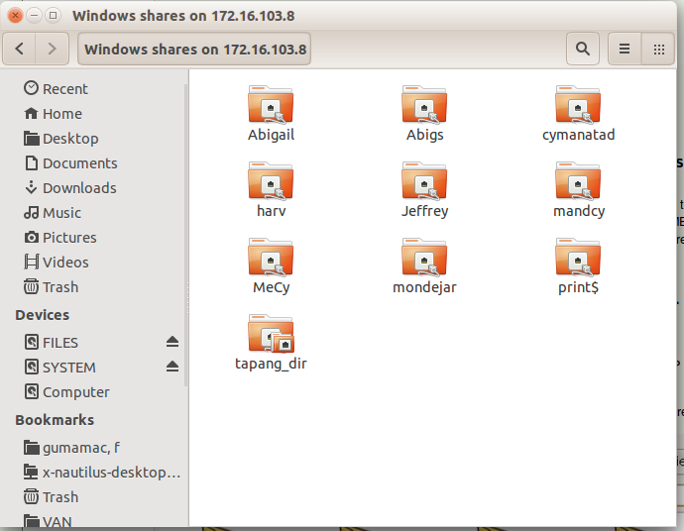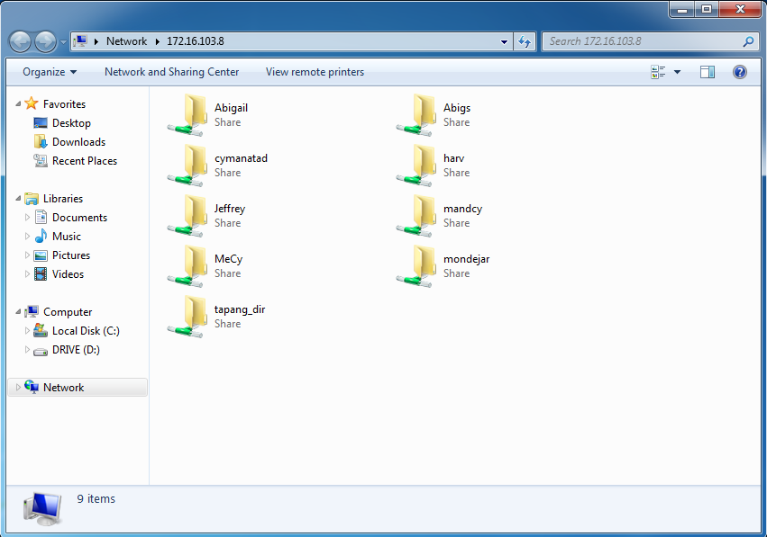

**My Folder**

**My Folder**